Mental Health Dataset

Data Exploration & Analysis

Univariate visualizations:
Two bivariate visualizations for each variable
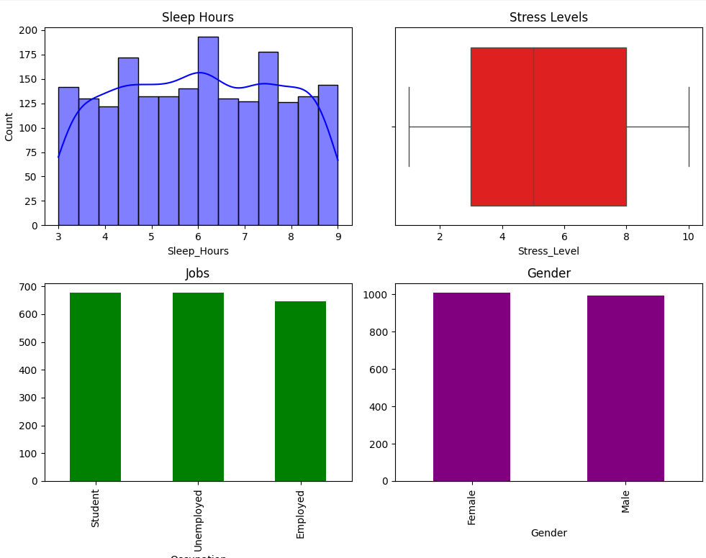

Quantitative:
- Sleep_Hours
- I chose the histogram approach when deciding to plot out the Sleep_Hours column of the dataset because it is a continuous quantitative variable. A histogram works well for showing the distribution of frequency ranges, as it helps indicate whether the data is standard normal or skewed to the left or right.
- Stress_Level
- I chose a Box Plot for Stress_Level because it is a discrete quantitative variable that is better viewed as a statistical snapshot than as individual points. While raw data can be hard to interpret, the box plot clearly breaks the population's stress experience down into a five-number summary: the minimum, maximum, median, and the two quartiles. I used this specifically to highlight the Interquartile Range, which shows where the middle 50% of respondents fall. This also serves as visual proof of my earlier QA check; any outliers would be flagged as dots outside the bounds. Since none appear, it confirms that all stress levels remain within the expected 1 to 10 scale without error.

Qualitative:
- Occupation
- I used a Bar Chart for Occupation. Qualitative and Categorical data are best presented using a Bar Chart. I compared whether the occupation was unemployed, employed, or a student, and a bar chart best displays the frequencies for each variable, thereby showing the counts.
- Gender
- Gender was displayed using a Bar Chart as it suits qualitative variables, in this case, categorical ones. The best way to analyze categories is to compare group sizes. Using a Bar Chart, I displayed the frequency counts for each group so that an analyst and a stakeholder could clearly see the highest representation for each group in the dataset.
- Using this Bar Chart method, one can distinguish between categories like female and male to see significant differences, like in gaps. Bar charts are great for generic counts, as qualitative variables cannot be used in statistical analysis.

Independent sample T test
The T statistic is used to assess the size of the difference between two groups relative to the data's variation.
Comparing one categorical variable with two groups against a continuous numerical variable.
Gender Vs Sleep_Hours
Is there a statistically significant difference in the average Sleep_Hours between Male and Female respondents?

Hypotheses
Null
No significant difference in mean sleep hours between males and females.
Alternative
There is a significant difference in the mean sleep hours between males and females.

Results:
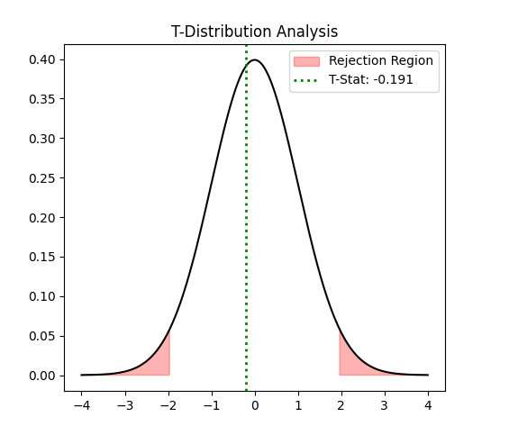

Mean comparison: Virtually no difference
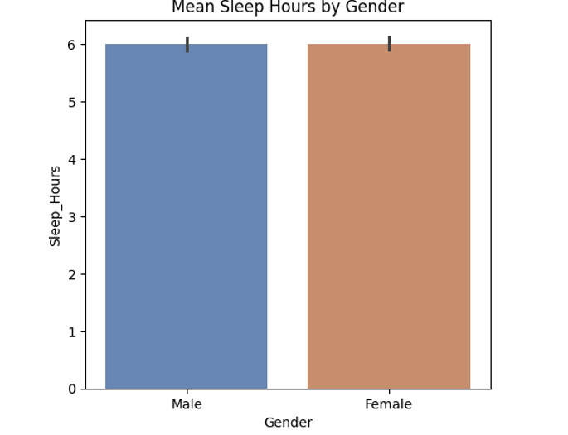
There is insufficient data to reject the null hypothesis
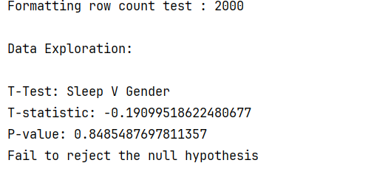
The P-value of ~0.85, which is much higher than the standard significance level of alpha = 0.05, and the T-statistic of -0.19, which is close to zero, indicate that the group means are almost identical, as the closer to zero the T- statistic is to zero, the less of a difference there is between the two means. I fail to reject the null hypothesis because. The observed difference in mean sleep hours between the two groups is too small, suggesting it is due to random chance rather than a clear difference between the two populations.
To best illustrate the significance of the T statistic, one needs to see the area of rejection, which would be the red area, as the T statistic would need to be so significantly large to make a difference. The T statistic, as shown by the vertical dashed line, is not far from zero, indicating that the significance is visually apparent.

Nonparametric Statistical Testing
Mann-Whitney U Test (Differences in the distribution/rank of the data)
Is there a statistically significant difference in the distribution of Stress_Level and Employed individuals (Occupation)?
I chose to use the Mann-Whitney U Test because it is nonparametric, ordinal (1-10), and does not require normality. As this survey is based on rank data, the variable Stress_Level is best analyzed in this format, since a 5 or a 7 may not reflect the same level of stress that two individuals may experience.

Hypotheses

Null:
Both Students and Employed Individuals will have the same distribution of stress levels.
Alternative:
The distribution of stress levels will have a significant difference between the Students and Employed Individuals

Results:
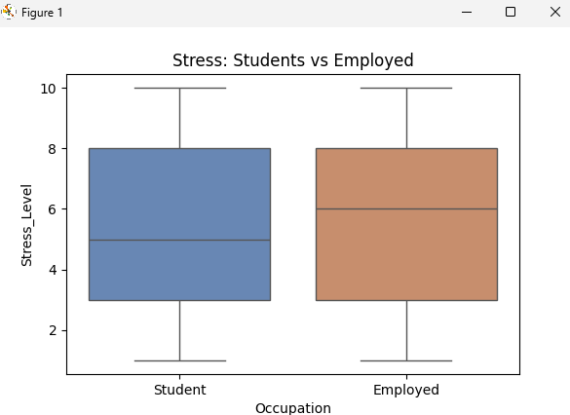

Fail to reject the null hypothesis
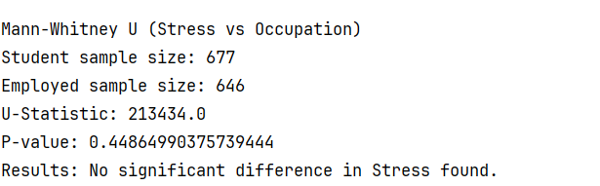
There is no significant difference in the distribution of stress levels between Students and Employed Individuals. The P-Value is ~0.44, higher than the standard alpha value of .05.
Given that the Mann-Whitney test uses a U statistic to determine if there is a significant difference between the distribution of two independent groups. The U statistic represents the number of times the Student group was higher than the Employed group, and it compares every possible pair.

Analysis Summary & Limitations
Technical limitations impacted this dataset. The sample size was large enough to perform normalized descriptive statistics, but they were weighted towards certain groups, as there were not enough of others to compare more fully, such as Employed Individuals and Students. Data subjectivity was also an issue. How can one accurately measure Stress Level? Sure, I used the Mann-Whitney test for this case, but if there were more variables like this, all depending on subjects' feelings rather than hard, measurable data, the analysis itself could be considered unreliable.

Conclusion
In this dataset, both tests returned high p-values, indicating that the difference was not large enough to reject either null hypothesis. One’s gender does not dictate one’s sleep hours, nor does one’s occupation dictate one’s stress level.

